**VARUN KUMAR**

**2K19-IT-140**

**OOP LAB – 6**

**#include <iostream>**

**using namespace std;**

**class employee{**

**int empid;**

**string name;**

**int salary;**

**static int bonus;**

**employee(string n , int e ,int s){**

**cout<<"private constructer called "<<endl;**

**name=n;**

**empid=e;**

**salary=s;**

**}**

**public:**

**static int no_of_objects;**

**void get_data(){**

**cout<<"Enter name , empid , salary: "<<endl;**

**cin>>name>>empid>>salary;**

**}**

**void print_data(){**

**cout<<"name: "<<name<<endl;**

**cout<<"empid: "<<empid<<endl;**

**cout<<"salary: "<<salary<<endl;**

**}**

**int bonus_offered_non_static(){ //non static function accessing static variable**

**bonus=(salary*2)/10000;**

**return bonus; //WORKS**

**}**

**// static int bonus_offered_static(){ // static accessing non static variable**

**// cout<<"static member function called "<<endl;**

**// bonus=(salary*2)/10000;**

**// return bonus; //ERROR**

**// }**

**static int return_bonus(){ // static accessing static variable**

**cout<<"static member function called "<<endl;**

**return bonus; // WORKS**

**}**

**static void private_Call(string n,int e ,int s){**

**employee(n,e,s); // static member function calling private constructor**

**}**

**employee(){**

**cout<<"default constructor called"<<endl;**

**no_of_objects++;**

**}**

**};**

**int employee::no_of_objects=0;**

**int employee::bonus=1000;**

**int main(){**

**employee e1,e2,e3;**

**e1.get_data();**

**cout<<"objects created: "<<employee::no_of_objects<<endl;**

**cout<<"bonus_offered: "<<employee::return_bonus()<<endl; // static member function called**

**static employee e4; // static object created**

**// It's constructed until the end of the program**

**e4.get_data();**

**employee e5;**

**e5.private_Call("vansh" , 6 , 100000); // static funbction**

**e1.print_data();**

**return 0;**

**}**

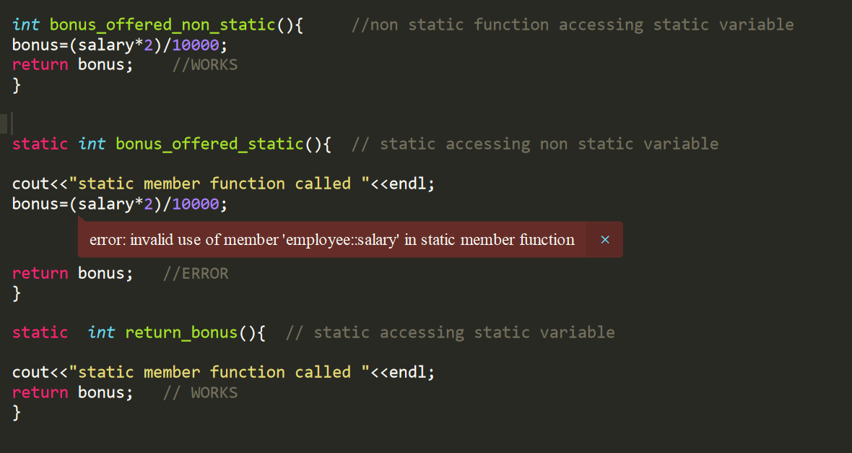

**ERROR WHILE STATIC MEMBER FUNCTION ACCESSING NON STATIC VARIABLES**

